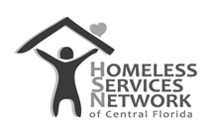

HMIS Document
Client Track User Guide

Homeless Services Network of Central Florida
4065-D L.B. McLeod Road
Orlando, FL 32811
Phone: (407) 893-0133
Fax: (407) 893-5299
www.hsncfl.org

Upon initial log in to ClientTrack, the home screen dashboard is displayed (see image below). To get started, use the menus on the left to create or select a client. At first login, there will not be a viewable recent list, however, after the first session; the user will see their recent clients on the user dashboard. To search/create a client in the system:
- Navigate to the client workspace by clicking the Clients Icon in the blue menu on the left.
- Click “Find Client”
First Login
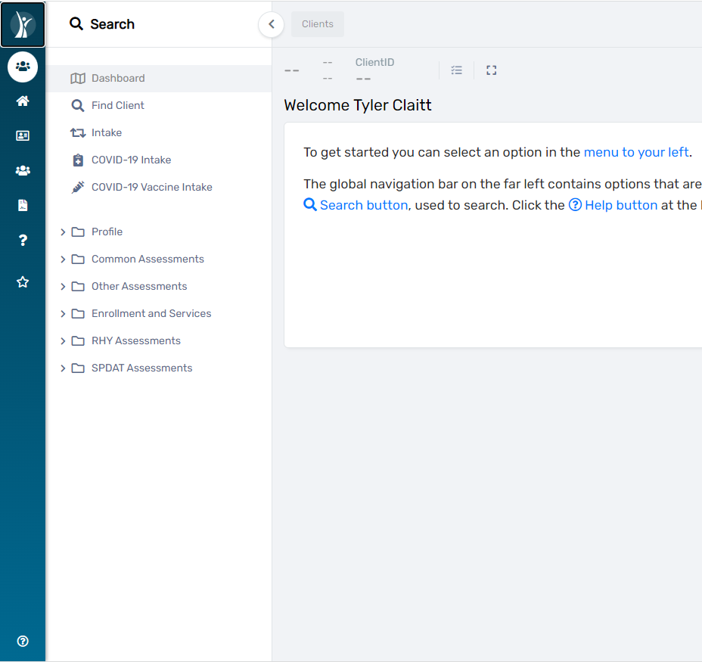

- Search for a client using the name, social security number, and/or date of birth.
- Select them at the bottom of the screen in the search results.
***note you will only have to do this the first time you ever login.

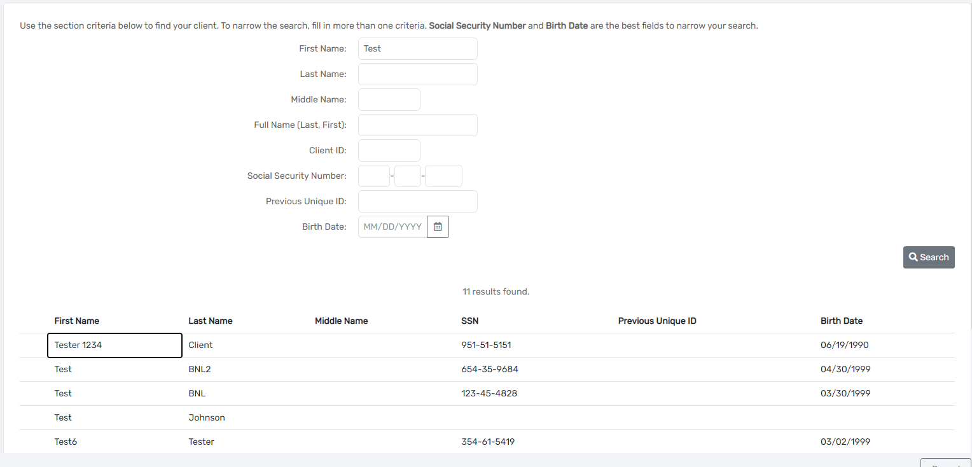

Intake
Creating a Client
- To create a client, click on the “Intake” menu option.
- Then click “Add new client”.
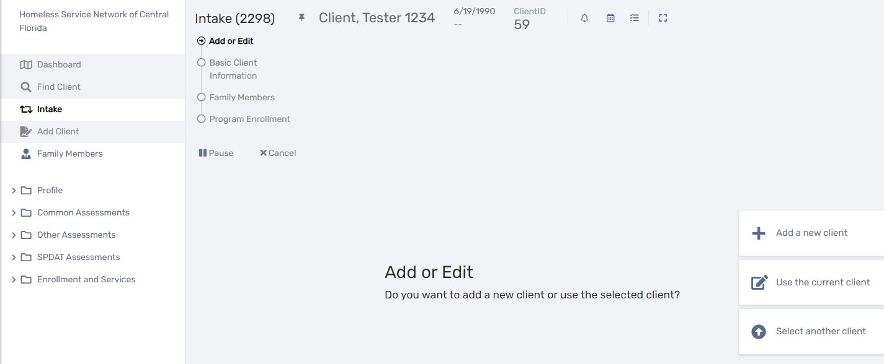
- Search for the first and last name of the client.
  - This is done to minimize the number of duplicate clients in the system
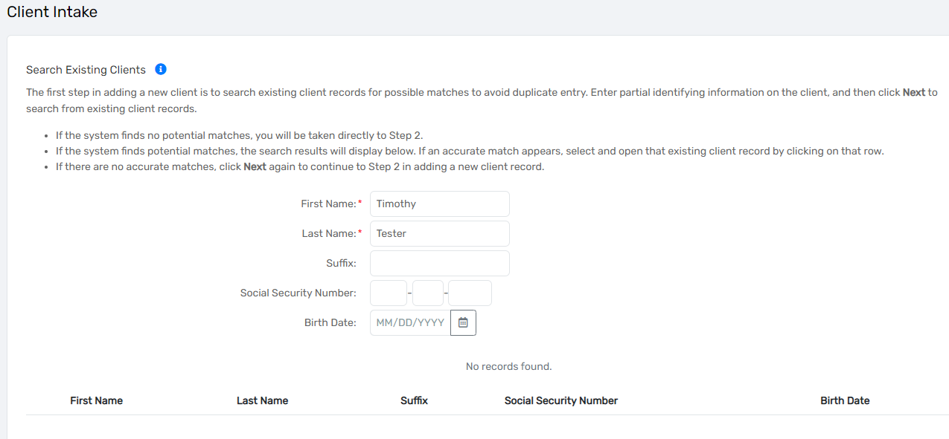
- Fill out the information for the client
  - First Name
  - Last Name
  - SSN
    - SSN Quality will go away once a full social security number has been added.
  - DOB
    - Birth date quality automatically updates once a birth date is selected
  - Gender
    - This is a multi-picklist field.
  - Marital Status
    - Although this is not required, it is highly encouraged
- Click Next
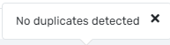
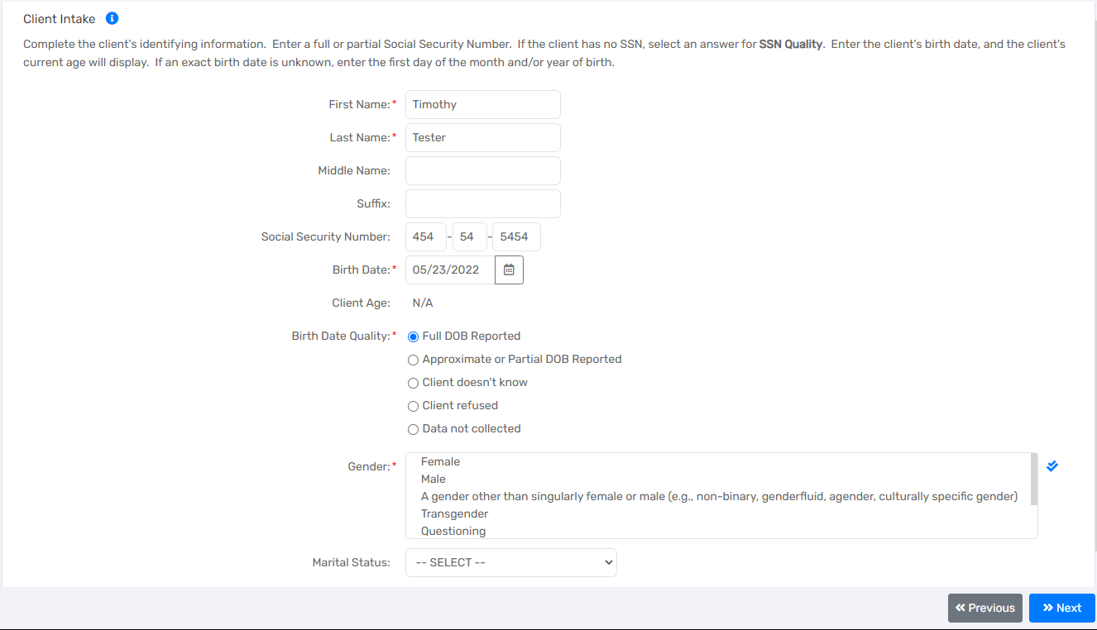
- Fill out the family and contact information
  - Family
  - Relationship to Head of Household
    - This required field is to ensure that the proper relation in a household is chosen for the client.
  - Family Address
  - Family Zip Code
  - Family Home Phone
  - Mailing Address
  - City/State/Zip
  - Different Residential Address
  - Home phone
  - Mobile Phone
  - Work Phone
  - Email

This section is referring to the county where the client became homeless.
- County of Homelessness
  - Recorded Date
  - What county were you in when this episode of homelessness began
  - County
  - State
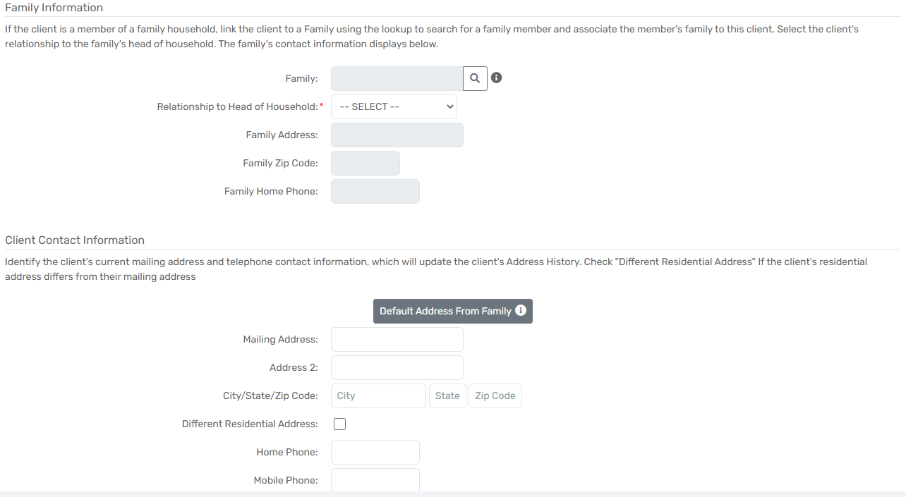
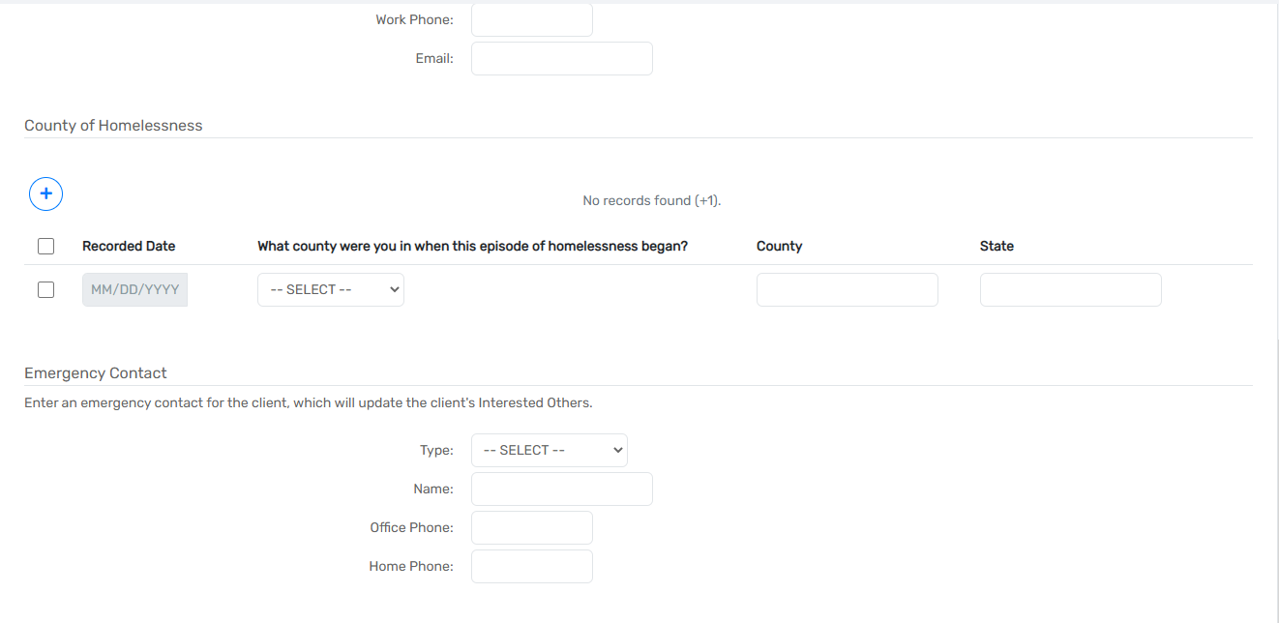
- Emergency Contact
  - Type
  - Name
  - Office Phone
  - Home Phone
- Client Billing
  - Enable Client Billing
  - Create new account
- Click Next

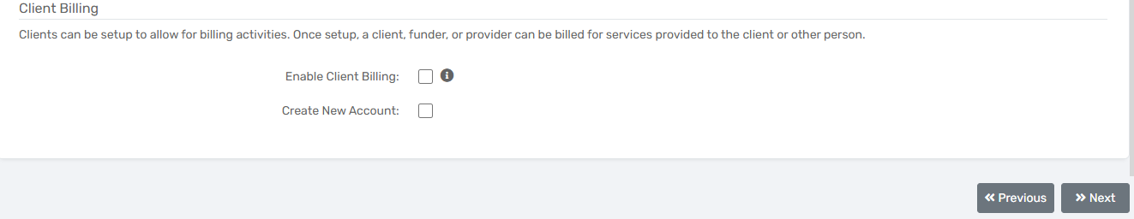
- Demographics
  - Ethnicity
  - Race
  - Religious Preference
  - Disabling Condition
  - Veteran Status
  - Primary Language
  - Limited English
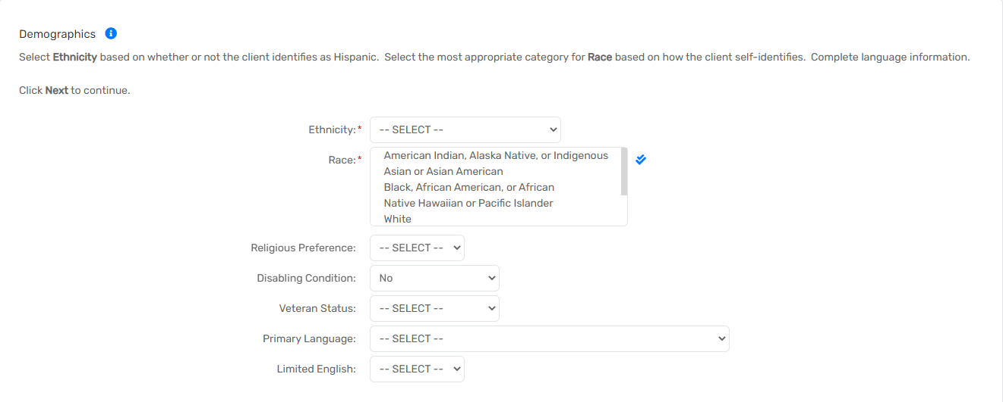
- Citizenship
  - Citizenship Status
  - Country of Origin
  - Alien Number
  - Entry Date
- Click Next
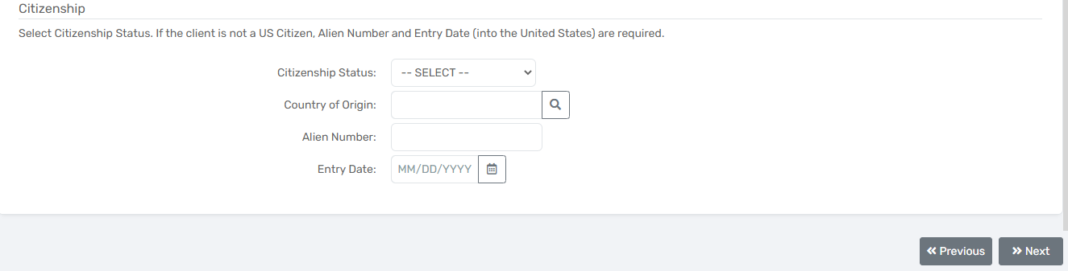
- Information Release and Security
  - Begin Date
  - End Date
  - Signature
- Click Finish
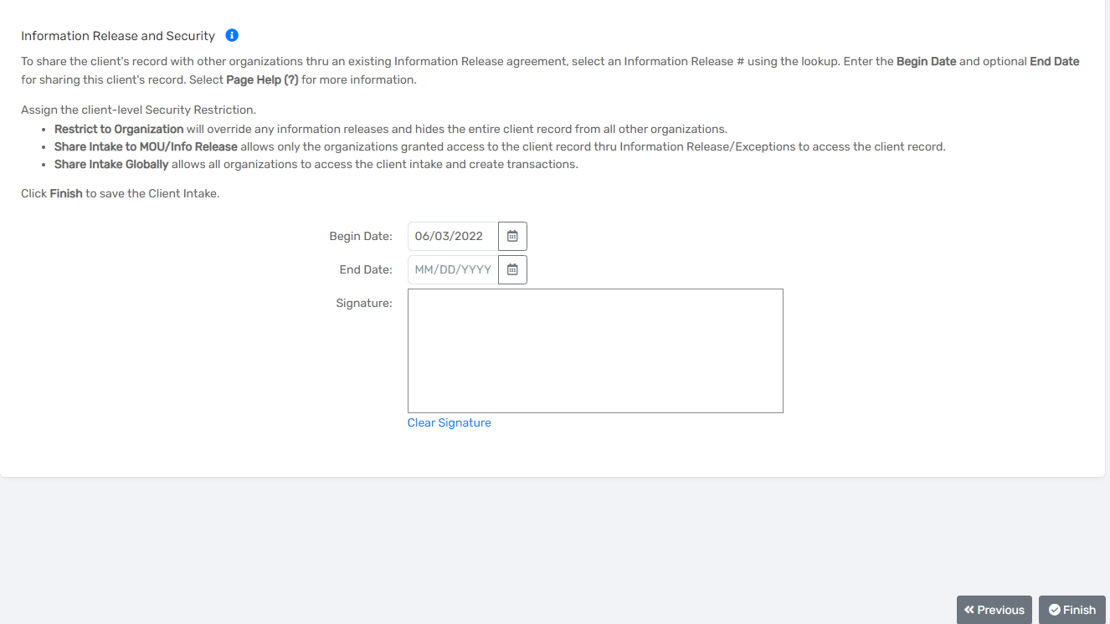

Adding Family members
To add additional family members you need to
- Select an empty slot starting with the first name
- Fill out each of the corresponding fields as shown in the picture below
  - Be sure to select a gender and race as these are commonly missed fields that will cause errors if you don’t make a selection for them
  - If the family member is a female you need to also select the pregnancy status
- Click save and close
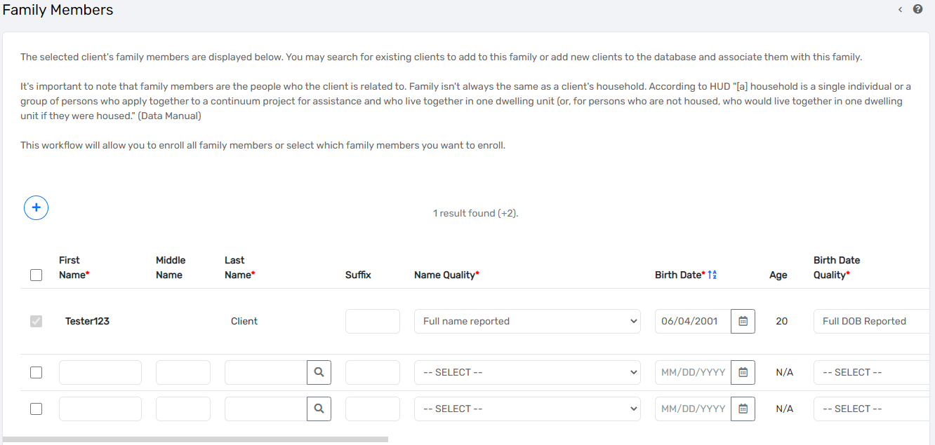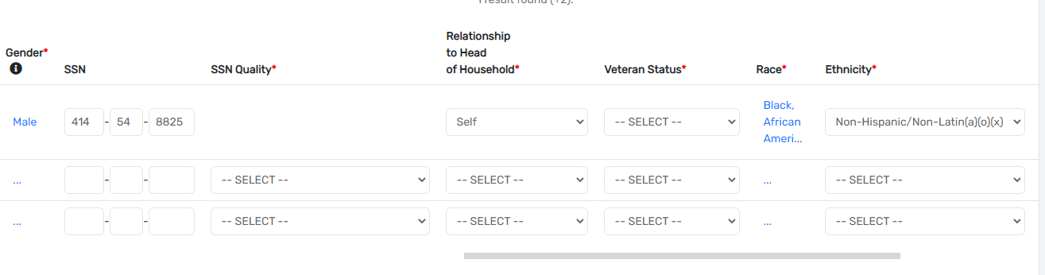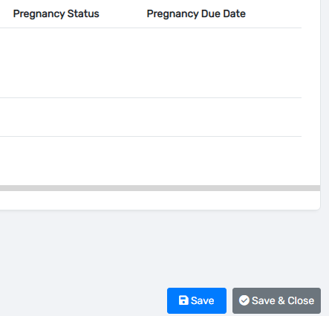
Now an enrollment can be added:
- Select an available project to enroll the client in
  - Depending on the type of project select you will see different options below

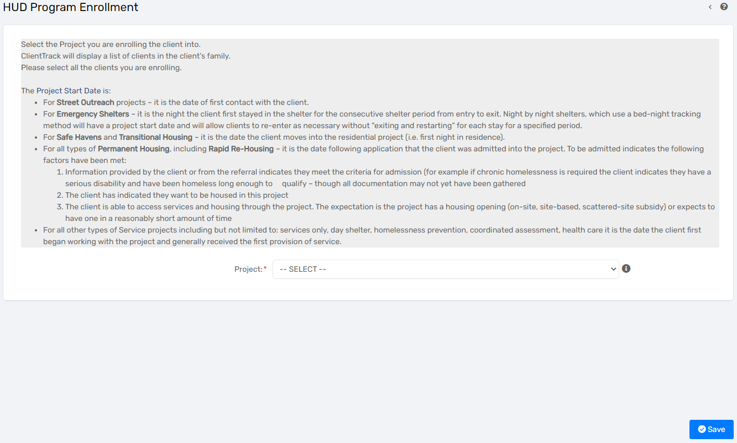
- The standard fields of the enrollment form are as follows:
  - Name
  - Gender
  - Age
  - Project Start Date
  - Exit Date
  - Case Manager
  - Relationship to head of household
- If selecting a Street outreach project you will see the standard fields plus:
  - Date of engagement
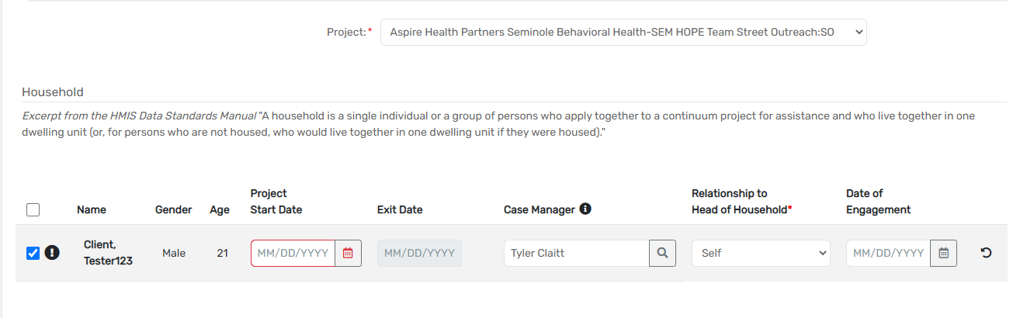

- If selecting a PATH Street outreach project you will see the standard fields plus:
  - Date of engagement
  - Date PATH Status Determined
  - Client became enrolled in PATH
  - Reason not enrolled in PATH

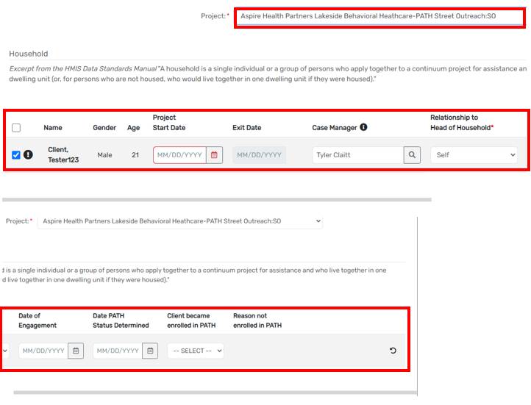

- If selecting a Permanent housing or Rapid rehousing project, it will show the standard fields plus:
  - Housing move-in date
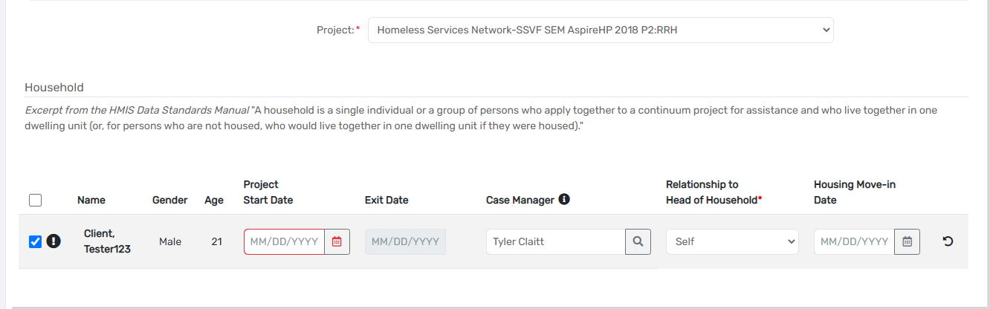
- The Standard fields of the top section of the Universal Data Assessment are as follows
  - Assessment Date
  - Age at assessment
  - Assessment type
  - Assessor
  - Program
  - Disabling condition
- Since the PSH project is also an SSVF project, the next page shows the standard fields plus:
  - Household income as a percentage of AMI
  - VAMC Station Number
- Client Location
- Living Situation
  - Prior living situation
  - Length of stay in the prior living Situation
  - Approximate date homelessness started
  - Number of times homeless
  - Total number of months homeless
- Address Prior to Entry
  - Quality
  - Address
  - Address 2
  - city/state/zip
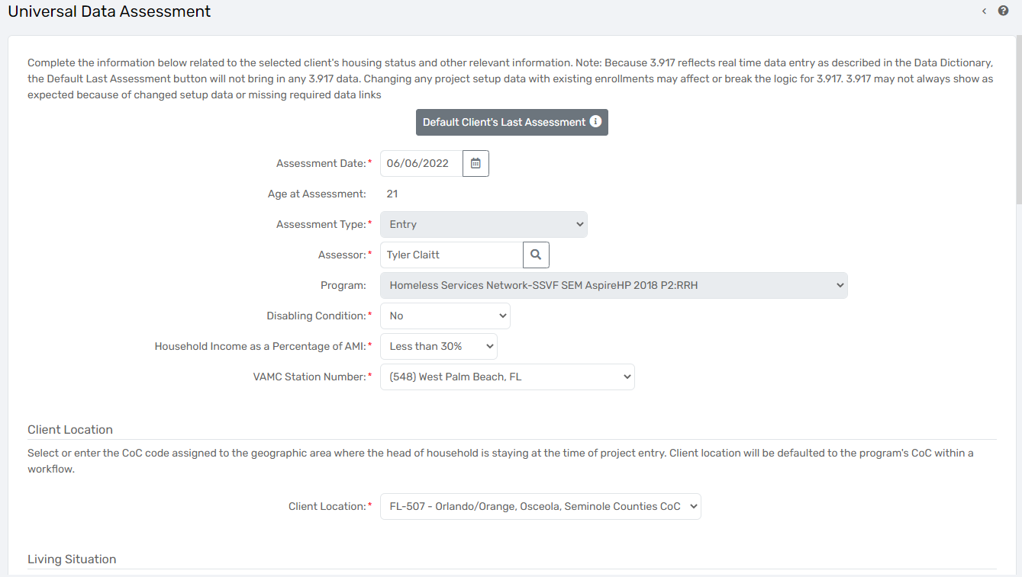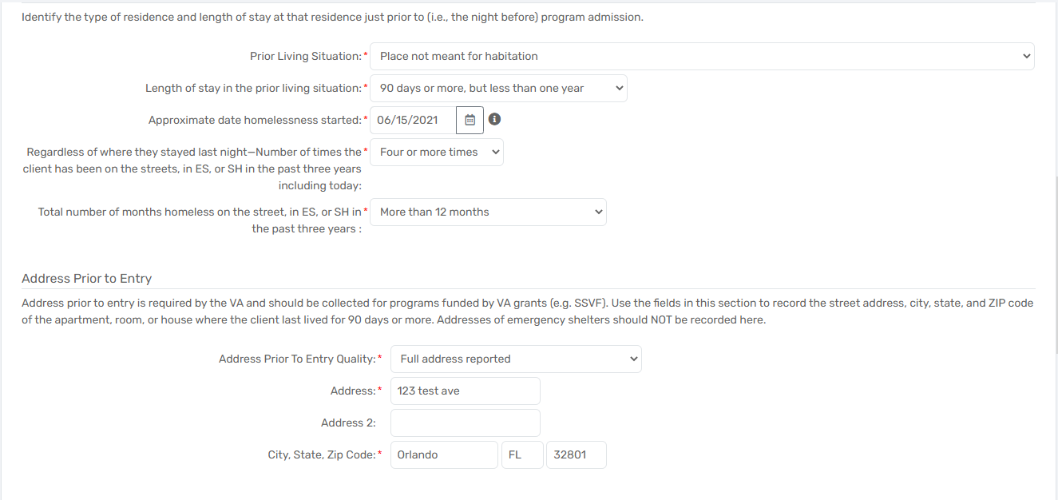

- Covered by health insurance:
  - If you answer yes to this question you need to make sure at least one of the sub fields are also a yes but each one needs an answer
- Click “Save”.

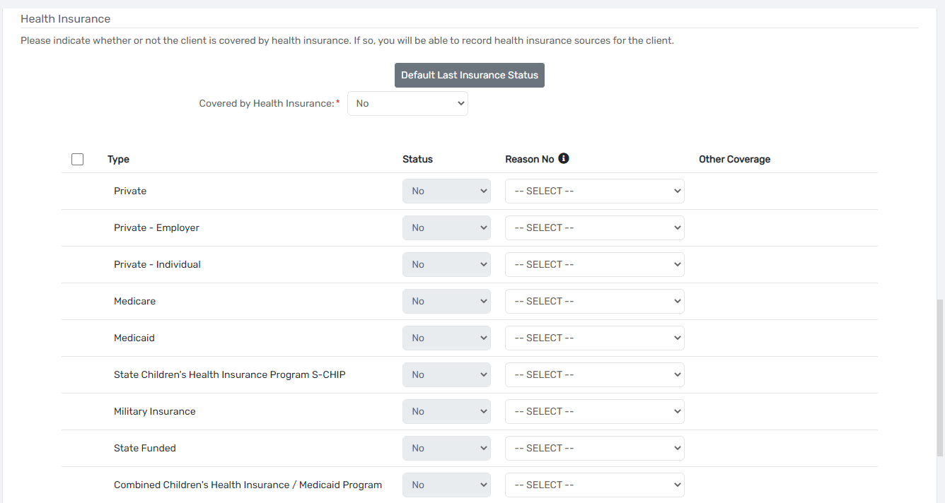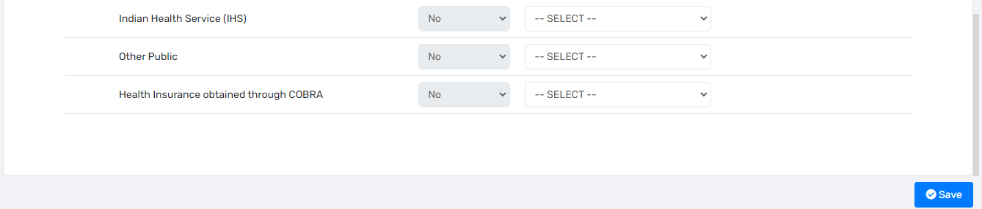
- This assessment is unique to SSVF:
  - Assessment Date
  - Employed
  - Why not employed or fulltime/parttime?
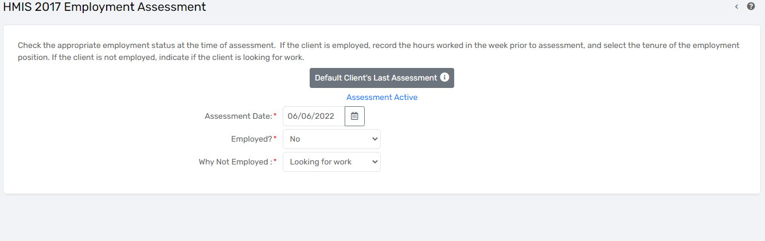
- This assessment is for disabilities:
  - If any of the answers are a yes, change the disabling condtion to yes and check the box next to the corresponding barrier
- Click “Save and close”
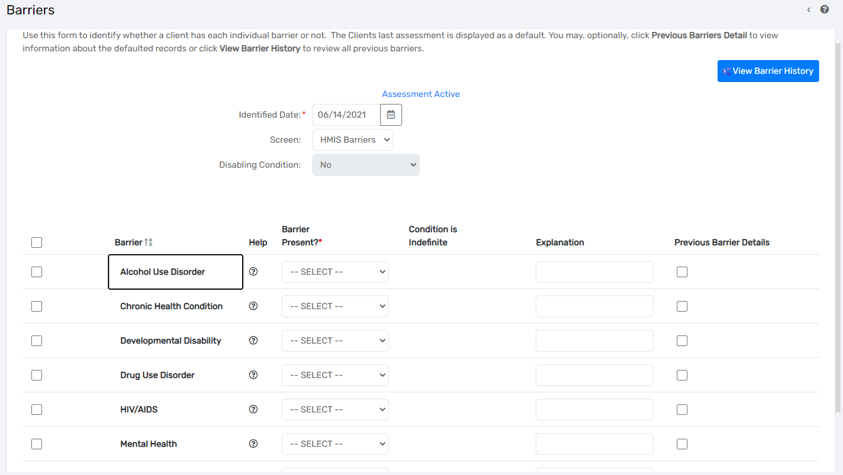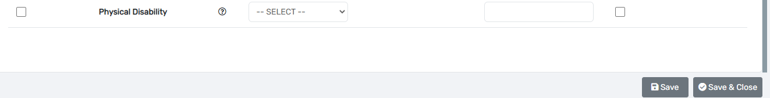
- The next step is to answer the DV assessment by answering “yes” or “no”
  - If yes, there are follow up questions as shown in the image below.
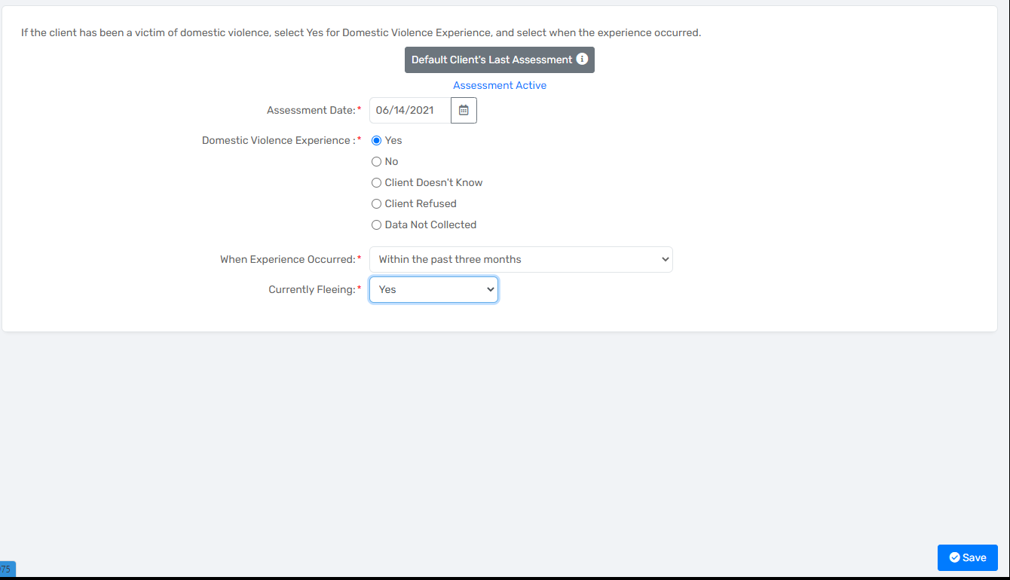

- The income and sources assessment has three required questions to an answer
  - If the answer is yes to any of the questions there will be more sub assessments that need to be answered
  - Once you answer all of the questions and sub assessments click save and close
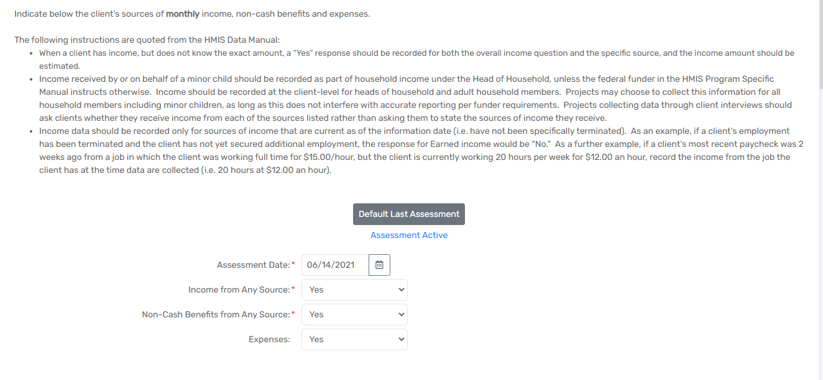
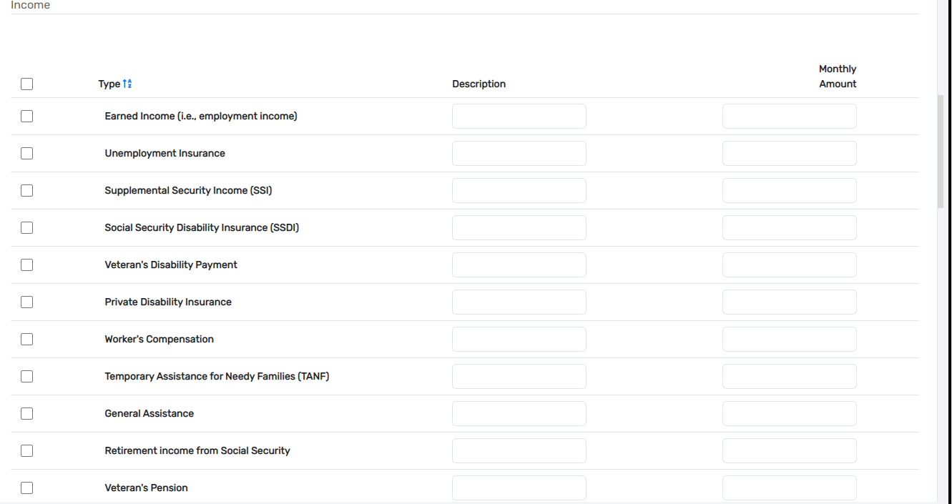 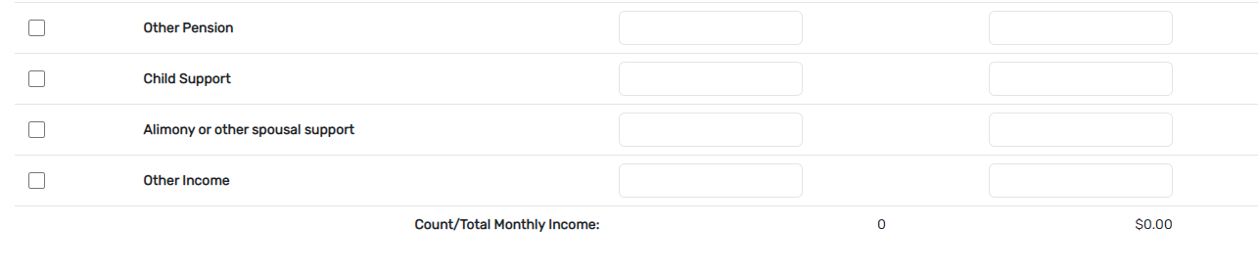 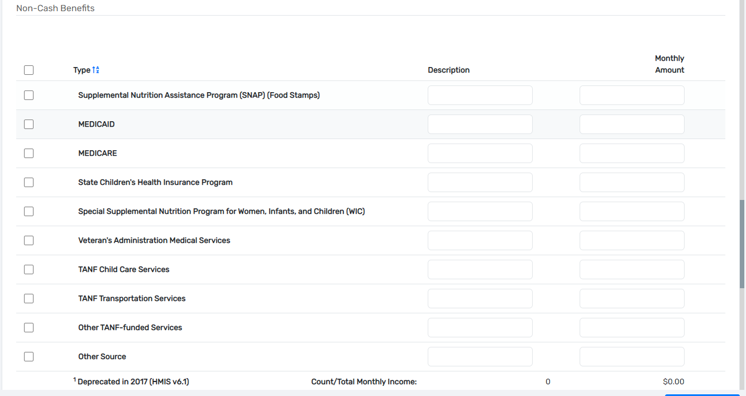 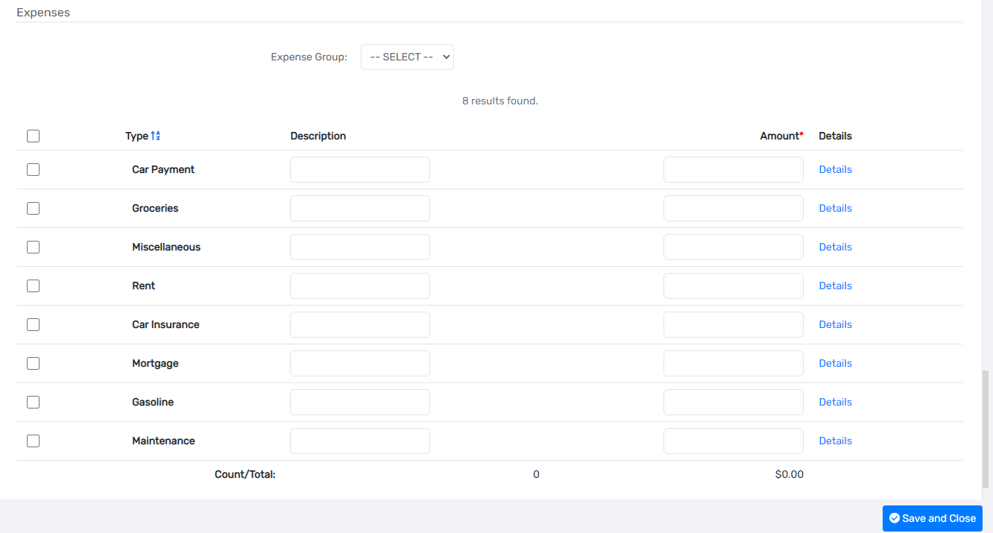Current Living Situation
- The current living situation is the last assessment in the intake
- The following fields need to be filled out in order to move forward
  - Current Living situation
  - Contact Service
- Although the othe questions aren’t required it is recommended that they are answered
- Click Save
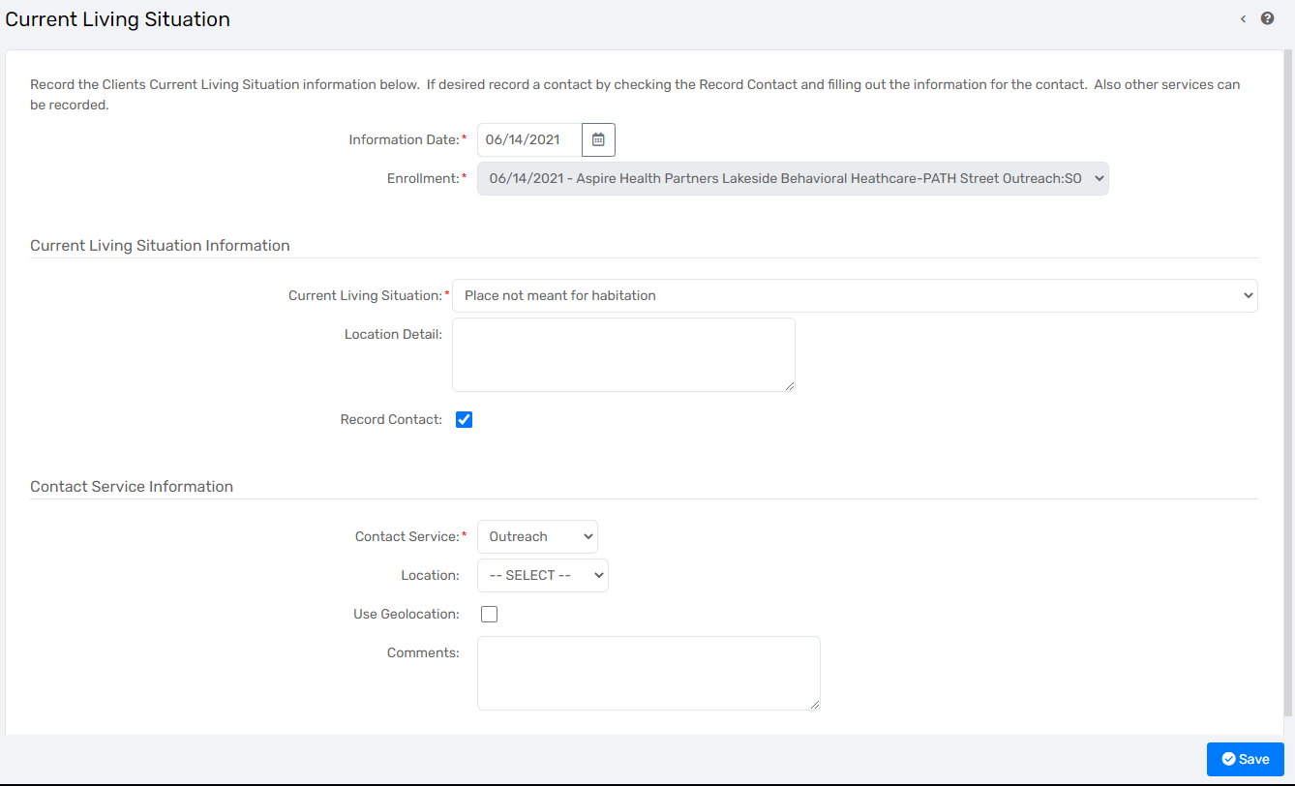

Update and annual assessment
- Go to enrollments while on a client’s record
  - Click on the three small dots icon in front of the program enrollment that needs an interim update or annual assessment added
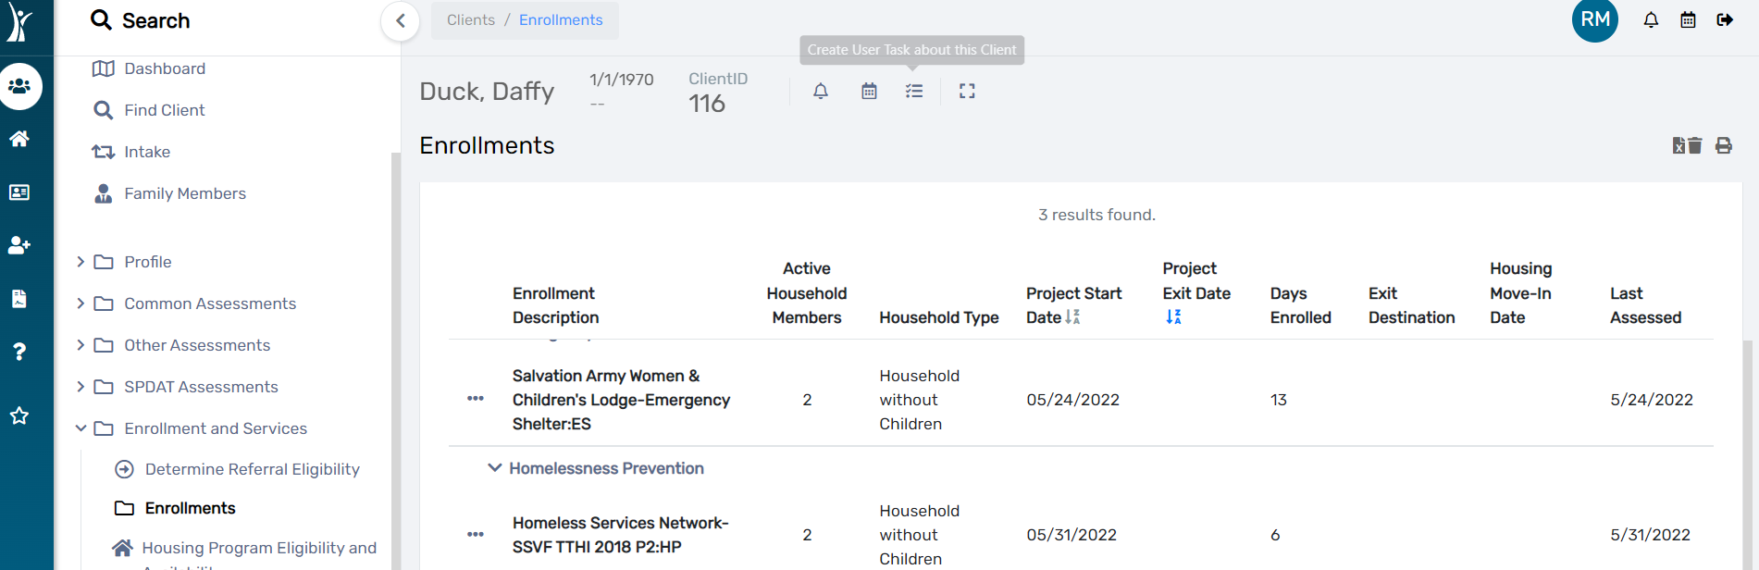
- On your list of assessment options, select “Update/Annual Assessment”
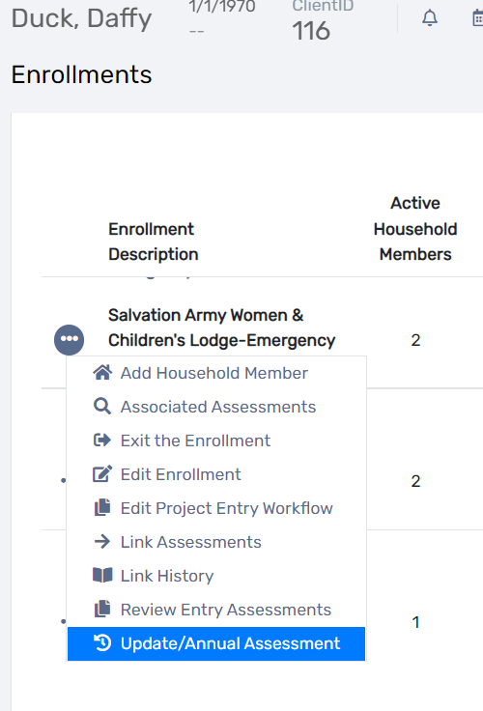
- Ensure the correct program is identified and the names of all affliated household members are listed and checked, then at the bottom right corner, click “Save”.
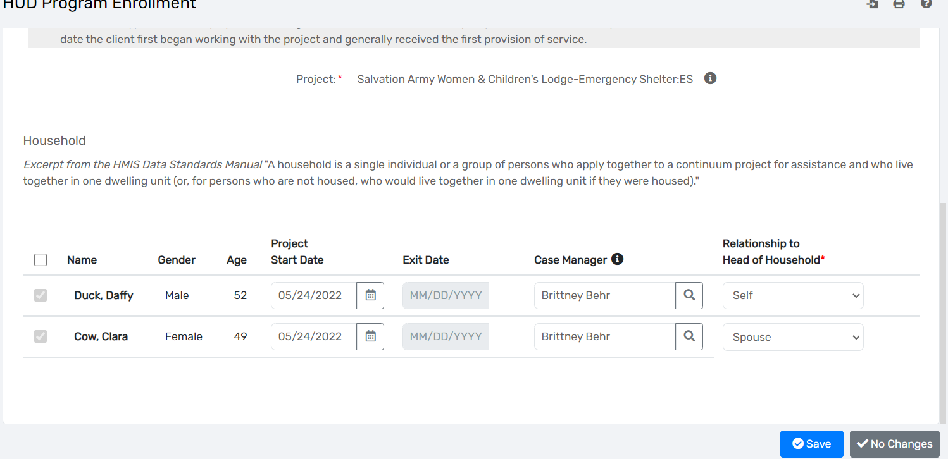

- Select your desired interim assessment, Update or Annual.
  - For an interim update assessment, select “New During Program Enrollment/Update Assessment” and;
  - To complete an Interim Annual Assessment, select the second option.
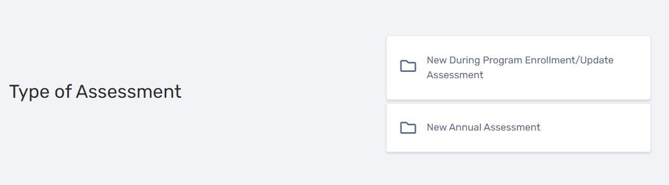
- The system will prompt you to complete the interim update or annual assessment across various screens for all affiliated household members. Complete each section and at the bottom right corner, select “Save” or “Save and Close” each time until the full assessment is complete.
  - You also have the option to “Default to Client’s Last Assessment” in cases where information has not really change and you’d like it to populate with the previous responses.
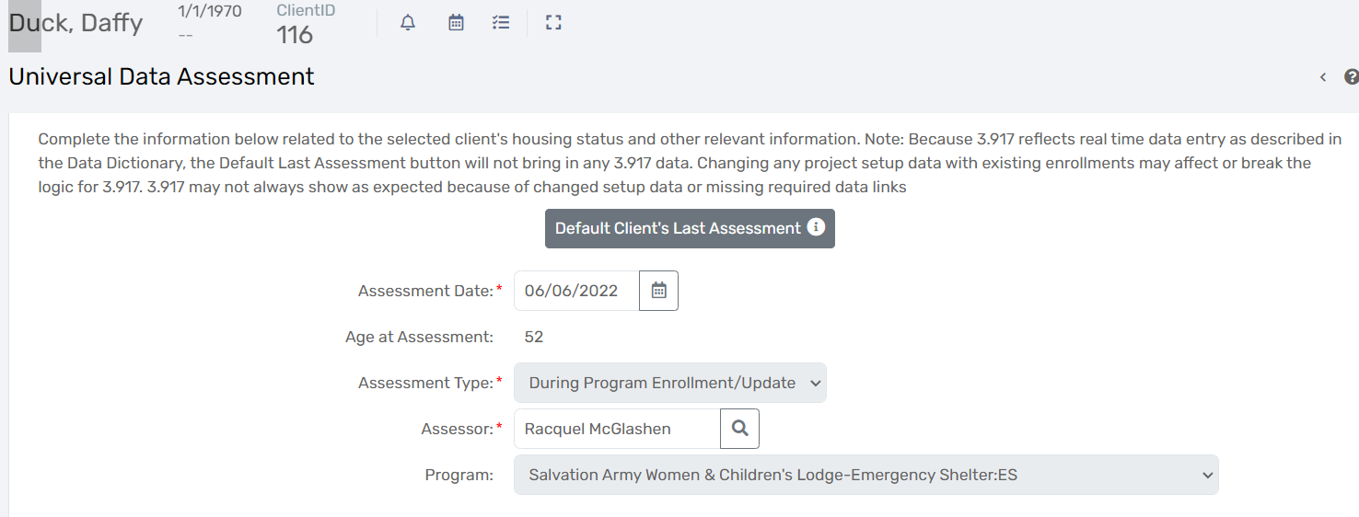

Goals / Services / Case notes
- There are two ways that case notes can be created in the system:
  - While on the client’s dashboard, you can click on the header “Client Goals” OR;
  - On the client’s menu on the left, you can expand menu options under “Profile” and select either Goal Planning (this ties case notes to the a specific goal) or select “Case Notes” (this allow user to add case notes not tied to a specific goal).
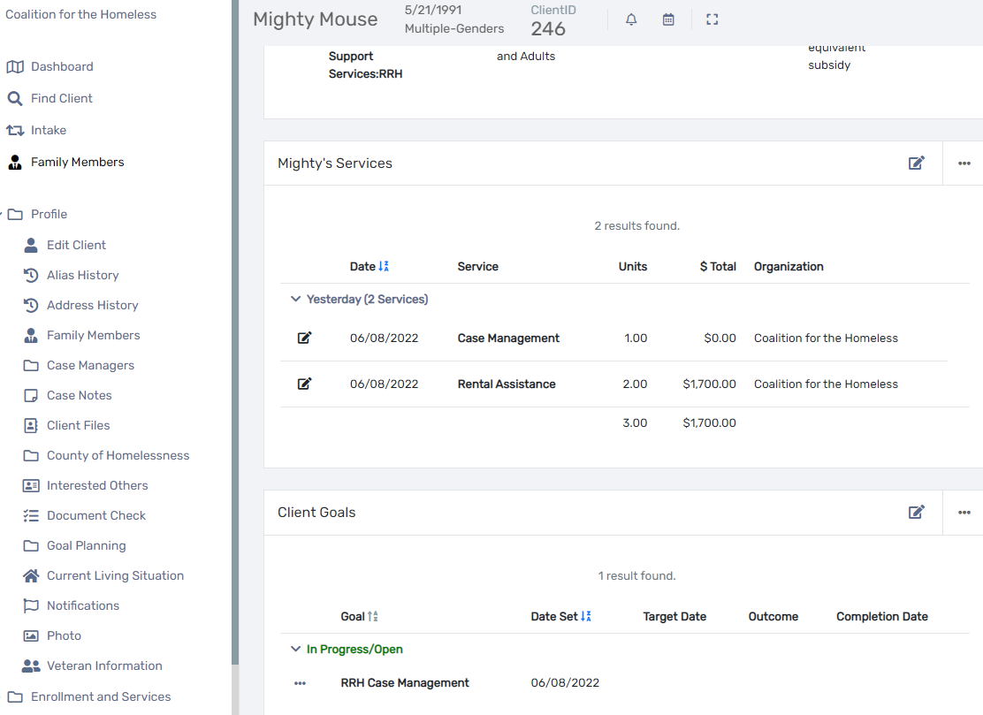
- If you click “Client Goals” on the client dashboard, or select “Goal Planning” under the Profile section in the menu on the left hand side, you will then be able to click on the blue button labelled “Add New Goal”.
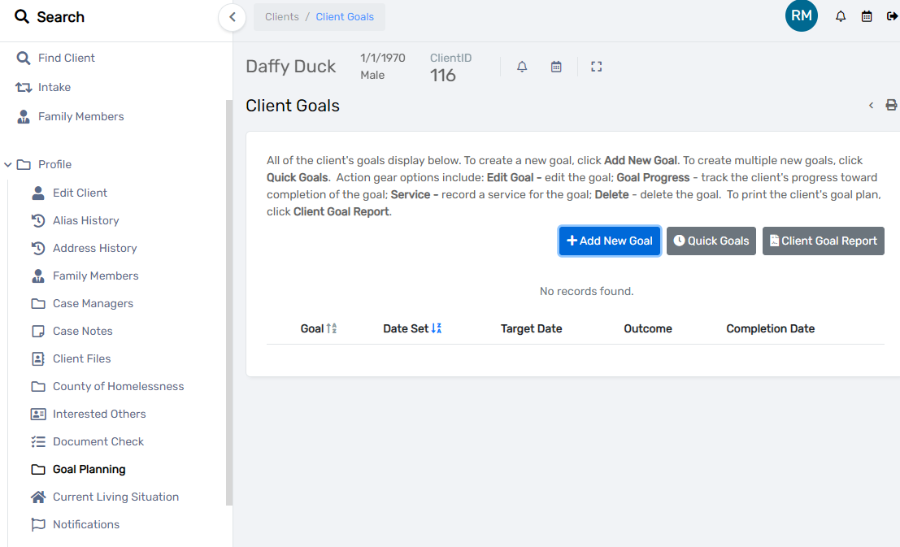

- Complete the goals form to begin an associated series of case notes.
  - Status: Identify if the goal is in progress/open, identified, or closed.
  - Goal Type: Identify is the goal is long-term or short-term.
  - Goal Group: Identify a goal category.
  - Goal: Identify a specific goal related to the group goal.
  - Goal Description: Type in a short few words to describe the goal.
  - Goal Date: Enter the date the goal was set.
  - Target Date: Enter the tentative date for accomplishing the set goal.
  - Enrollment: Select the related program enrollment.
  - Associated Need/Barrier: If any, select a related assiciated need/barrier.
  - Explanation: Type a description of this goal in better detail.
    - Tip: Click the three small dots at the top left corner of the explanation box to format your text (font, color, size, etc).
- Once the form has been completed, click “Save” at the bottom right corner.
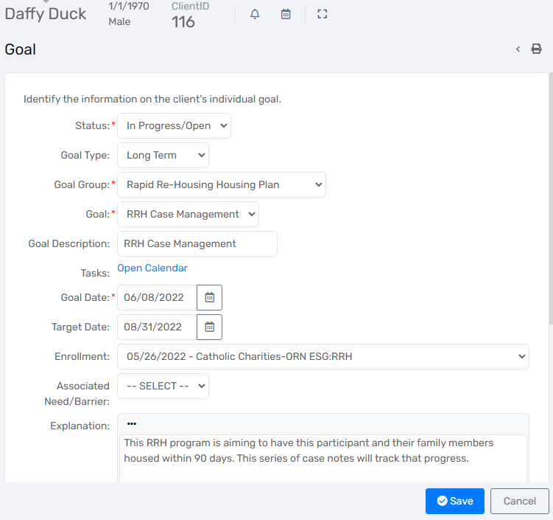
- Under client goals, click the three small dots at the beginning of a row to do the following:
  - Edit the goal.
  - Update the progress of the goal.
  - Add an associated case note(s).
  - Add an associated service.
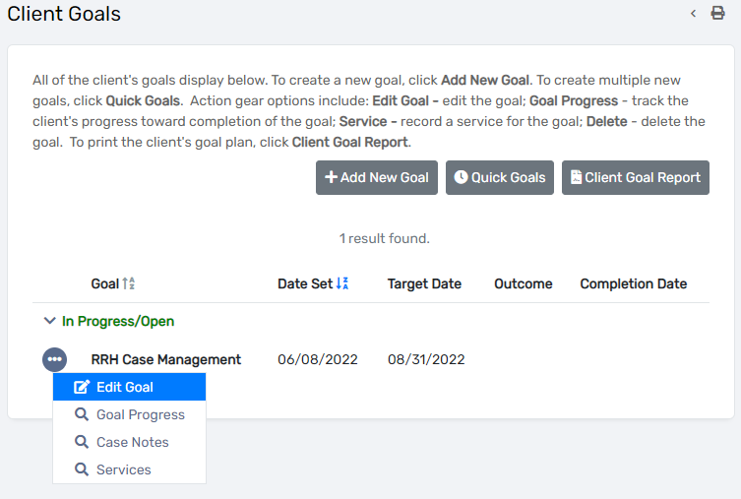
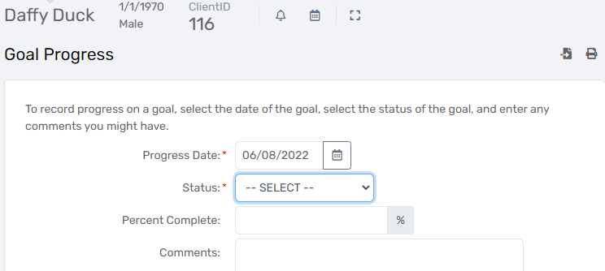
- Under “Goal Case Notes”, click the blue button “Add New” and then proceed to complete the case note form.
  - Entry date
  - Case Manager: Verify the assigned case manager. You can manually type a different name or use the magnifying glass to search for a user in the system.
  - Regarding: Enter a brief subject header or description title for the case note.
  - Case Note text box: Type in the actual case note.
    - Note: All case notes created are viewable by all system users. They are only editable by the creator and other users at their organization. Below the case note text box, there is an option to check whether you’d like to create the text box as “read-only” so that no one other than the creator can make edits.
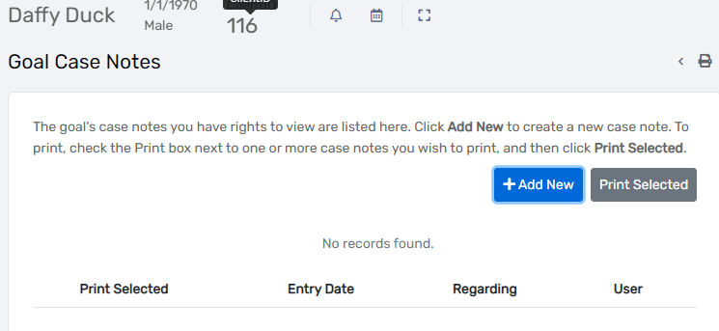
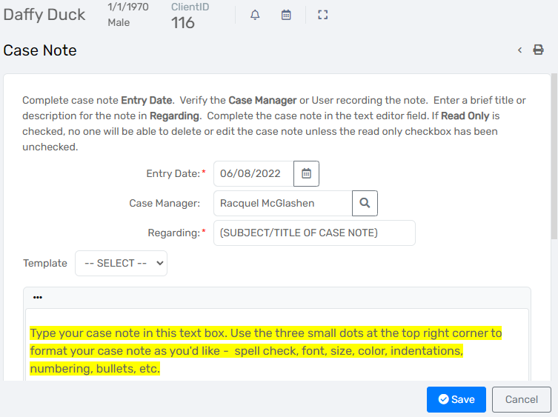
- You can attach services to a goal by selecting the option “Services” from the Client Goals screen (using the three small dots at the front of the row for the selected goal”.
  - Click the blue button at the top right corner labelled “Add New”
  - Complete the services form:
    - Enrollment: Select the program associated with this goal.
    - Grant: If applicable, select an associated grant/funding source for the service.
    - Service: Select the service that was provided.
    - Date: Enter the date the service was provided.
    - Units of Measure: Select a unit of measurement
      - For financial services such as rental assistance, select Dollars.
      - For non-financial, such as case management, select minutes or hours.
      - Enter a count to identify the frequency of service in this record.
    - Unit: Enter how many of that service was provided (eg 2 months of rent, or 10 bus passes)
    - Unit Value: Enter the dollar amount is applicable
    - Total: This field will autopopulate once unit and unit value is completed.
    - User Performing Service: Verify or enter the name of the person providing the service.
    - Comments: Add any additional comments/details about this service.
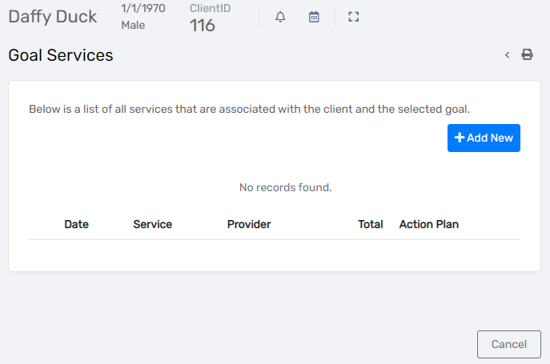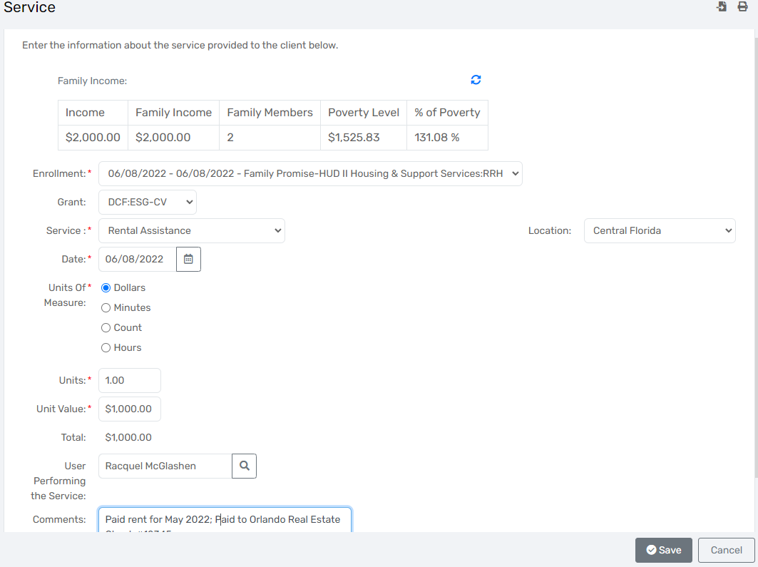
- Case notes that are not linked to a goal may be added using the client’s menu to the left side of the screen.
  - Expand the options for “Enrollments and Services”
  - Click on “Services”
  - Click “Add New Service”
  - Enter service details on the following screen and click “Save” at the bottom right corner.
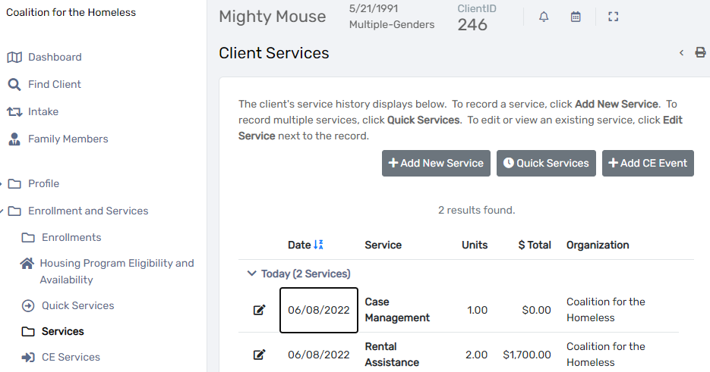

90 Day Recertification Assessment (for SSVF)
- While on a client’s profile, you can add custom assessments. Some of these are already built into standard assessments, while others such as the SSVF 90 day recertification assessment, are not. To get to these additional custom assessments:
  - On the left hand side where the client’s menu options are, expand “Other Assessments”.
  - Select “SSVF Re-Cert”.
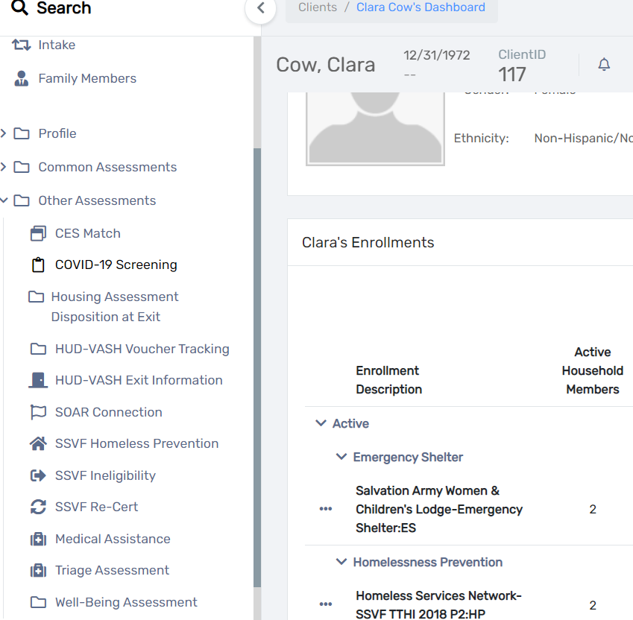
- Once on the SSVF Re-Cert page, if there are previous records for this client, you will see them listed below.
  - If you are documenting a new SSVF Re-Cert, click “Add New” at the top right corner.
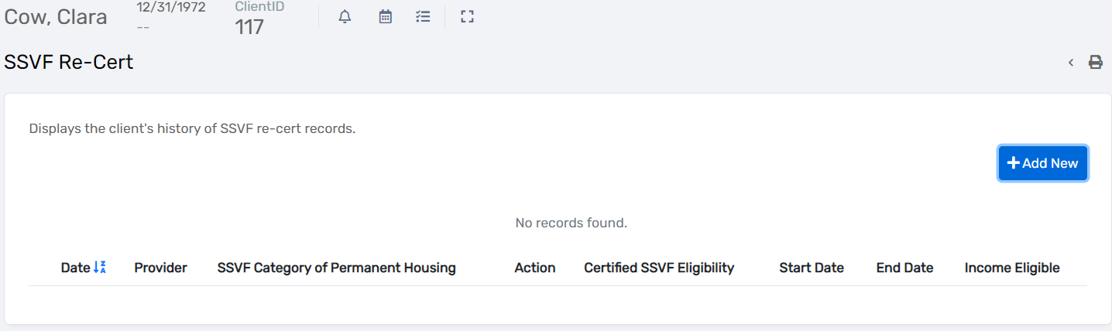
- Complete the SSVF Re-Cert assessment and click “Save” at the bottom right.
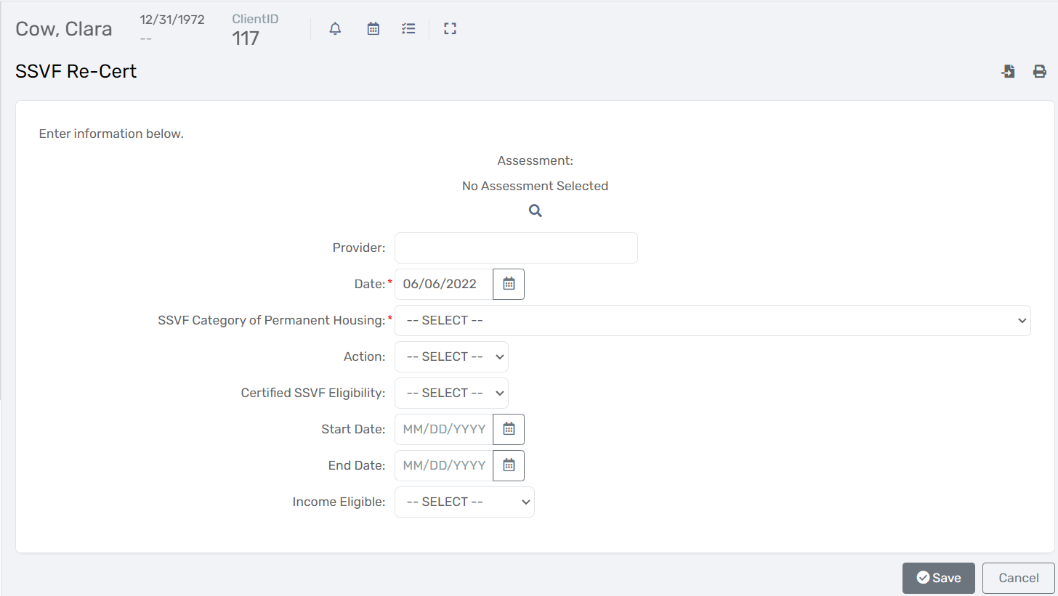
Ineligibility Assessment (for SSVF)
- While on a client’s profile, you can add custom assessments. Some of these are already built into standard assessments, while others such as the SSVF Ineligibility assessment, are not. To get to these additional custom assessments:
  - On the left hand side where the client’s menu options are, expand “Other Assessments”.
  - Select “SSVF Ineligibility”.
- Once on the SSVF Ineligibility page, if there are previous records for this client, you will see them listed below.
  - Click “Add New” at the top right corner to create a new assessment record.
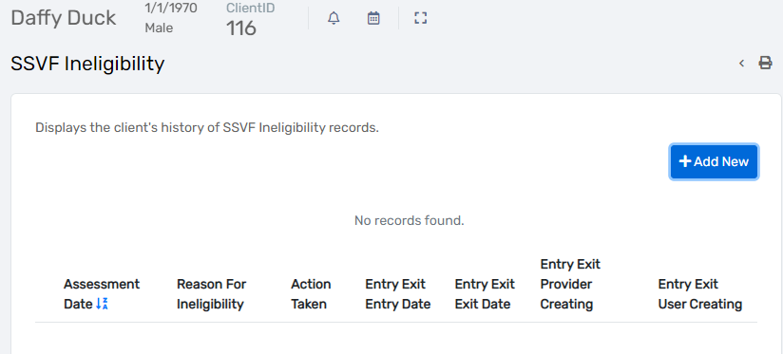
- Complete the SSVF Ineligibility assessment and click “Save” at the bottom right.
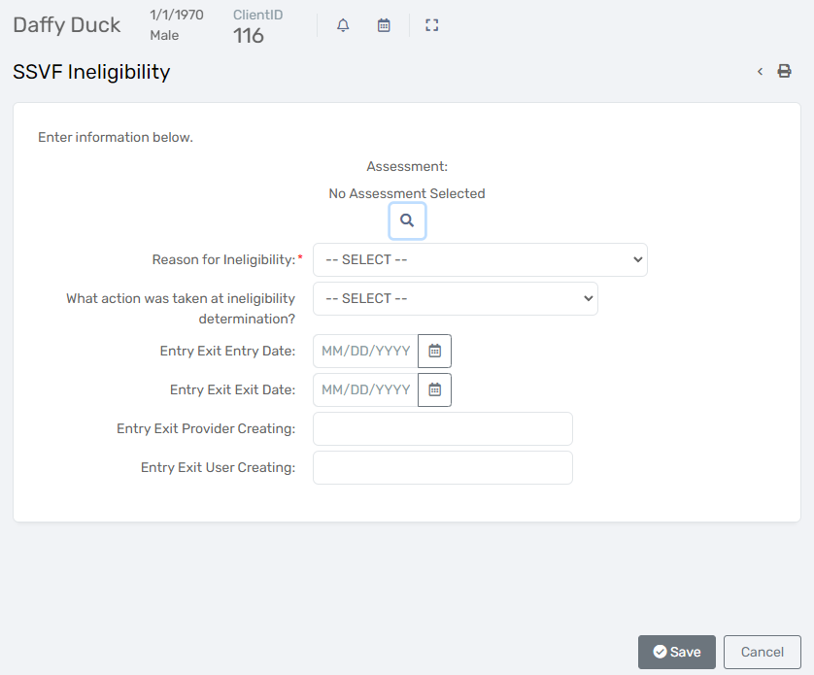
Document History

Date of Revision | Document Version | Revision Notes
2022/06/28 | 1.0 | First Release of Document

