BRIDGE HOUSING

WORKFLOW

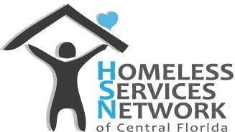



NOTE - This document will be updated once our community transitions to the new HMIS, to include the new HMIS referral workflow for the new system

PURPOSE
Bridge Housing (BH) is available to ensure participants with high needs are in a safe and accessible location while permanent housing is identified. Providing BH to those who are currently unsheltered will help mitigate the spread of COVID 19 in our CoC.

Agencies are strongly encouraged to use BH as a short-term option when housing in a specific unit is expected within 60 days or when a participant is especially vulnerable to illness or victimization. For cases that take longer to house, extensions will be considered as funding allows. Because BH funds are limited, not all requests will be granted.

ELIGIBILITY
To be eligible for Bridge Housing, an individual, youth, or family must;
  - Be matched to a Housing Stability Case Manager through the CES Registry Management process;
  - Have explored staying at shelters or with family or friends, and are unable to access those temporary shelter options; or participant is timing out of domestic violence shelter;
  - Be currently unsheltered or be in need of respite housing while their current unit is uninhabitable, hazardous or inaccessible.

WORKFLOW
Once the Housing Stability Case Manager has confirmed the participant is eligible, the Housing Case Manager may request Bridge Housing by following the workflow below.

Step 1 – Send a Referral in HMIS
Housing Case Manager submits referral in HMIS to “Homeless Services Network - Bridge Housing ES 850” for “Homeless Motel Vouchers”.
NOTE: If you do not have the option for selecting either “Homeless Motel Vouchers” or “Homeless Services Network - Bridge Housing ES 850”, send an HMIS helpdesk ticket (hmis@hsncfl.org) to request these fields be added to your Project/EDA referral options.

Sending a Referral in HMIS for Bridge Housing
- Ensure your EDA is set to your correct project ID/Name
- Go to Service Transactions Tab
- Click Add Referrals
- For Families, only select the Head of Household for the referral.
- Under Service Code Quicklist, select Homeless Motel Vouchers BH-1800.8500-300
  - Select Add Terms
- Under Referral Provider Quicklist, select Homeless Services Network – Bridge Housing- ES 850
  - Select Add Provider
- Scroll down to the bottom of the screen to ensure the following items are set:
  - Referred to Provider = Homeless Services Network – Bridge Housing- ES 850
  - Box is checked under Homeless Motel Voucher
  - Referred clients = Head of Household name
- Add a note by clicking on the note icon to provide any relevant information for the BH coordinator (ie: needs downstairs unit, has a dog, location needs due to safety concerns, etc.)
- Select Save All

HMIS Referral Visual Workflow
Add Referral
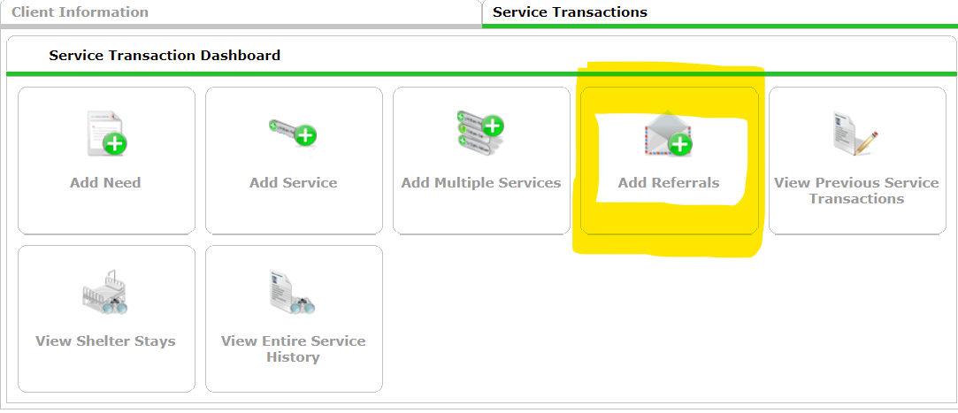

Select Need and Provider
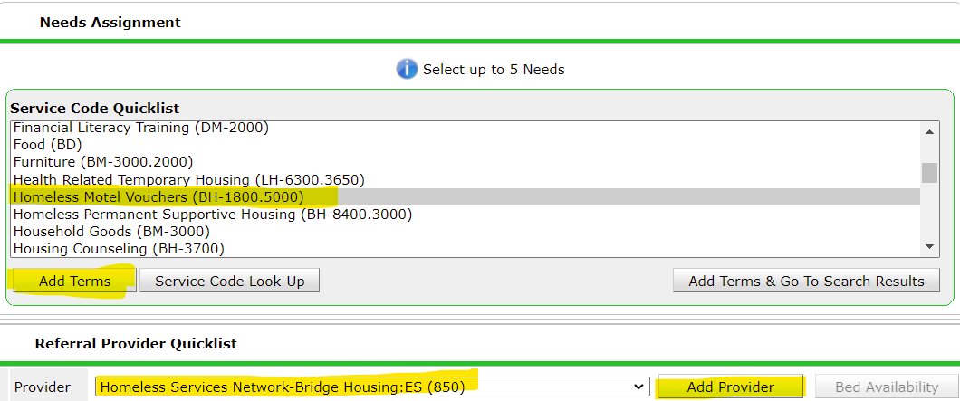
Confirm referral data, add any relevant notes, Save All.
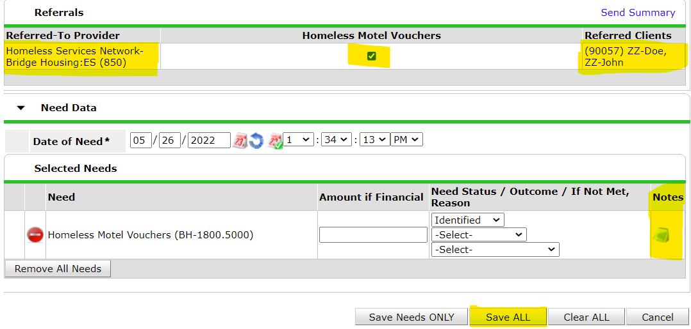

Processing the Referral
- Please allow up to 1 business day for the BH Coordinator to respond. The BH Coordinator will update the referral status in HMIS to either “Accepted” or “Declined”.
- Case Managers can also check the status of the referral by viewing the Service Transactions, viewing Referrals, and the referral outcome for the referral sent to HSN - Bridge Housing ES.
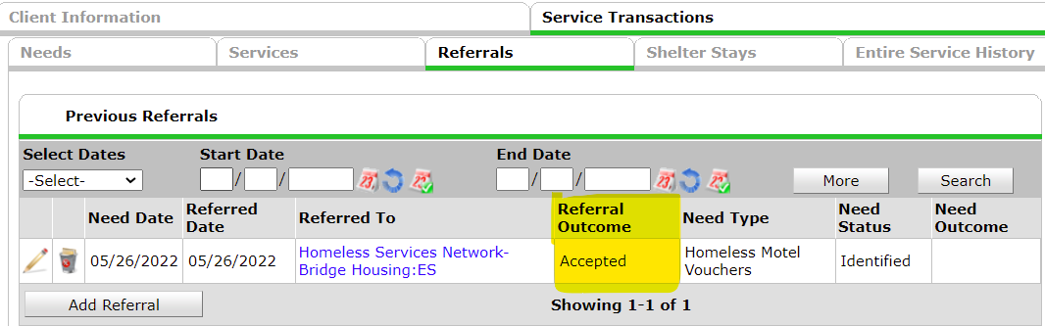

Step 2 – Placement into Bridge Housing
- Once Approved, Housing Stability Case Manager will email cocbridgehousing@hsncfl.org to:
  - Ask what HSN Hotel options are available;
  - Indicate when participant needs to check in; and
  - Provide any safety, medical or location preferences.
- BH Coordinator will let the Case Manager know the hotel address and check in time
- Case Manager must review, sign, and upload the Bridge Housing Agreement with participant prior to check in
- Case Manager should email cocbridgehousing@hsncfl.org to confirm the participant checked in.

Step 3 - Case Management while in Bridge Housing
- Case manager should plan for weekly hotel visits while the participant is Bridge Housed to encourage housing search, and stay up-to-date on participant status, needs, or challenges.
- Case Manager should work with participant on addressing barriers to housing, or any issues the participant is having in the hotel.
- If a participant has not been housed within 60 days of entering Bridge Housing, a Case Conference with HSN Housing Operations may be requested, in efforts to further assist in permanent housing.
- Bridge Housing Coordinators may complete random room inspections to ensure the safety of participants and the hotel unit.

Step 4 - Requesting Extensions in Bridge Housing, if needed
When a participant has been in BH beyond the agreed upon timeframe with HSN:
- Case Manager should request an extension by emailing cocbridgehousing@hsncfl.org, SUBJECT LINE - EXTENSION REQUEST.
- The body of the email should include the HMIS ID and a brief summary of the status of housing search and need for an extension.
- HSN will review case notes to determine if an extension request is an option and may schedule a meeting with the Case Manager if needed.
- Extensions are granted based on the availability of funds, as well as reviewing the housing search efforts of the participant.

Step 4 – Leaving Bridge Housing
Participants are exited from BH for any of the following reasons:
- No more funds are available
  - HSN will inform the program of a final date in BH based on no more funds available
- The hotel Management has asked the guest to leave due to issues with following rules
  - Hotel Management should provide notice to guests that they are being asked to leave due to issues following the rules.
  - Case Manager may contact CoCBridgeHousing@hsncfl.org to see if other BH options are available.
  - Any items left behind will be thrown in the trash.
- The participant has been housed
  - Case Manager should help participant clear out the hotel room within 3 business days after a lease is signed.
- Participant has been out of the room for 7 days
  - HSN will not pay on a hotel room once a participant has been out of the room for 7 days.
  - Case Manager should email the BH Coordinator to inform of the date the participant left the hotel and that they are expected to be out of the hotel for over 7 days (ie: jail, hospitalized.)
  - The housing program should gather any remaining items in the room that belong to the participant.
  - After the 7th day, the hotel will trash out any belongings in the room.

Once a participant leaves Bridge Housing
- Case Manager ensures the hotel staff know the guest has checked out.
- Case Case Manager emails CoCBridgeHousing@hsncfl.org to inform of date of exit & where they exited to (ie: permanent housing, friends, streets, jail, etc.)
- The Bridge Housing Coordinator exits the Bridge Housing entry in HMIS.

Attachment

Bridge Housing Agreement

to be reviewed with participant, signed, and uploaded in HMIS.
- Participant may not be served in BH if they refuse to sign the agreement

Bridge Housing Support Agreement
Below are the guidelines for receiving temporary hotel assistance, or Bridge Housing. While in Bridge Housing, your Case Manager will actively work with you to secure permanent housing as quickly as possible. There are a few items we want to review before you enter bridge housing. These guidelines ensure everyone stays safe while you work on finding housing.

While in Bridge Housing, your rights include:
1. The right to exercise your civil rights and religious freedoms;
2. The right to have your personal, financial, social and medical information kept confidential;
3. The right to receive courteous, fair and respectful treatment;
4. The right to present grievances on behalf of yourself and other residents to your assigned Housing Stability Case
Manager without fear of retaliation and to receive a timely response;
5. The right to manage your own finances;
6. The right to protections under the law as a victim of domestic violence;
7. The right to end your bridge housing stay at any time.

Guest Guidelines while in Bridge Housing
1. Follow the rules at your hotel’s location.
2. Smoking inside the hotel is not allowed, unless the room is a designated smoking room.
2. Stay fully clothed when leaving your hotel room.
3. If you have children under the age of 18, do not leave them in the hotel unattended in any location.
4. Guests are not allowed, unless approved by your Housing Stability Case Manager. You should notify the Bridge Housing Coordinator onsite of any approved guests.
5. Hot plates, stovetops, and toaster ovens are not permitted due to fire hazards and will be confiscated.
6. Please keep rooms clean and free of unnecessary clutter (Floors, walls, Bathroom, and sheets.) Room inspections will be conducted at any time.

The following actions will lead to immediate discharge from Bridge Housing:
1. Bringing weapons and/or any illegal substances to the hotel.
2. Violence, threatened violence, or other illegal conduct is not permitted and may be reported to law enforcement.
3. Acts that endanger the health and safety of yourself or others, including other guests or hotel staff.
4. Perpetrating domestic violence, sexual assault, stalking, or intimate partner violence.
5. Damage to the hotel room or property.
6. Smoking in the rooms or doorways of the room, unless the room is a designated smoking room.
7. Participants are not allowed to video other guests.

I understand and voluntarily agree to the terms of this Agreement. I understand that if I or my family do not follow the above guidelines, we may have to leave the hotel site and have our temporary bridge housing assistance discontinued.
___________________________ _________________________ _________
Participant Printed Name Signature Date
----------------------------------------------------------------------------------------------------------------------------------------------------------------
By signing below, I confirm I have reviewed this agreement form with the participant.
______________________________ __________________________ ____________
Case Manager Printed Name Signature Date
CM Uploads copy in HMIS – Participant keeps original

